Port forward.

* Expose port for the outer world
* 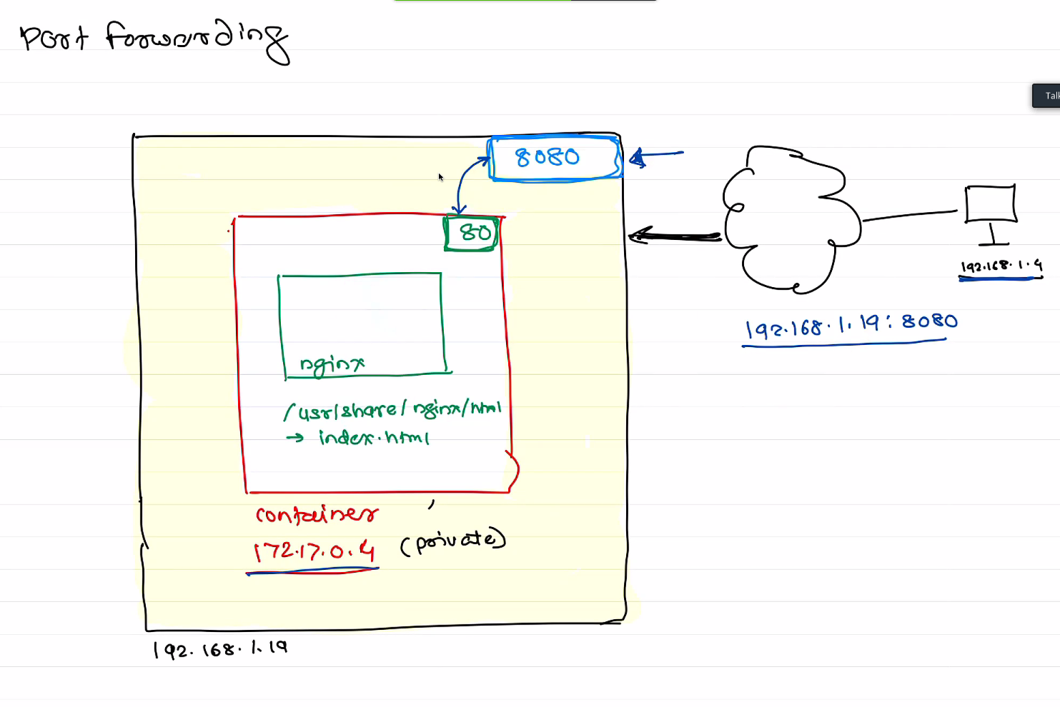

docker container run -itd --name nginx -p 8080:80 nginx

- create a container with port forwarding nginx( coz if -itd its running in detached state)

docker container exec -it nginx bash

-ssh into the container

docker run -itd --name apache -itd -p 8081:80 httpd